智慧教室

Smart Classroom

在這個專案中，你會打造一間能對你的語音指令做出反應的虛擬教室

In this project you will make a virtual classroom that can react to what you say to it.

你能透過語音來控制教室裡的虛擬物件

You’ll be able to control the virtual devices in the classroom by saying what you want.

你會透過給各種範例讓電腦學習辨別不同指令

You will teach the computer to recognise commands for different devices by giving it examples of each.

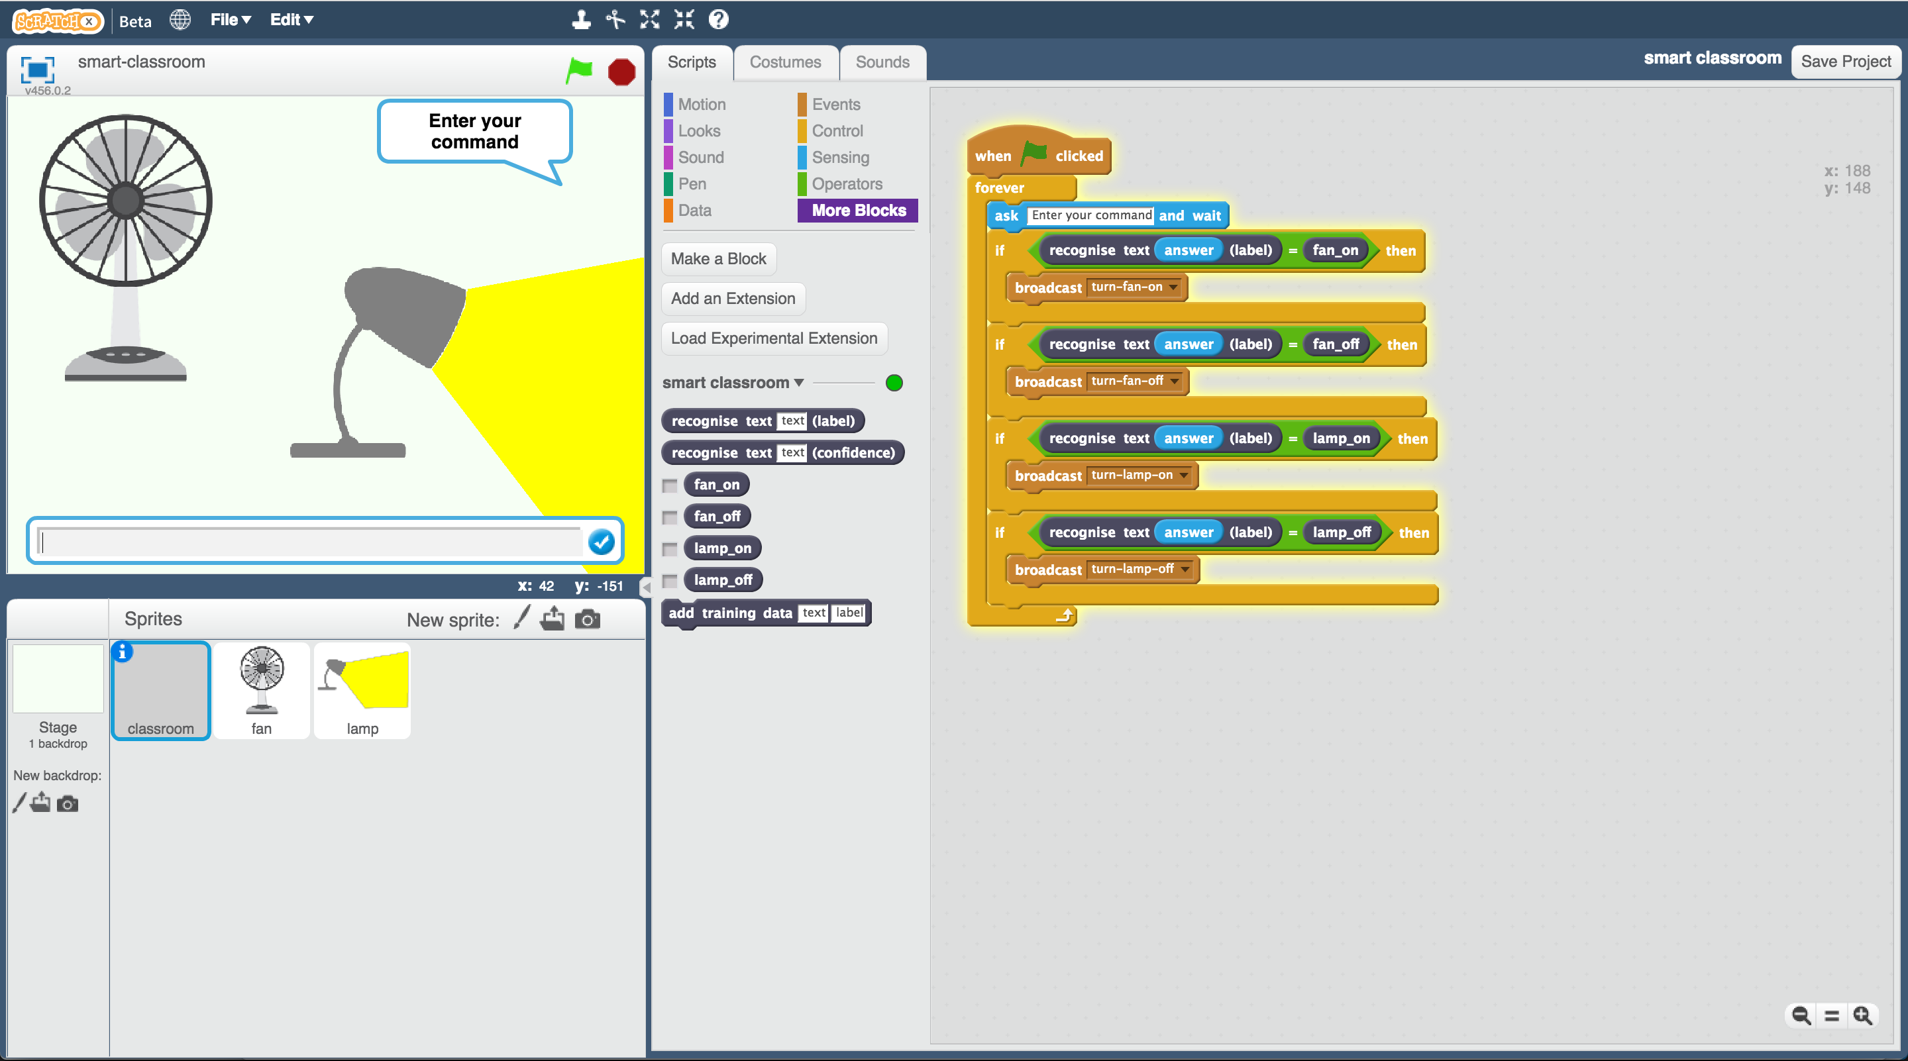

Creative Commons LicenceThis project worksheet is licensed under a Creative Commons Attribution Non-Commercial Share-Alike License

http://creativecommons.org/licenses/by-nc-sa/4.0/

1. 搜尋網頁：<https://machinelearningforkids.co.uk/>

Go to <https://machinelearningforkids.co.uk/> in a web browser

1. 點選“**Get started**”按鈕

Click on “**Get started**”

1. 點選“**Log In**”按鈕並登入系統

*如果你沒有帳號，請你的老師幫你建立一個帳號。*

*如果你不記得你的帳號或密碼，請你的老師幫你重新設定一次。*

Click on “**Log In**” and type in your username and password  
*If you can’t remember your username or password, ask your teacher or group leader to reset it for you.*

1. 點選上方清單中的 **”Projects”** 按鈕

Click on “**Projects**” on the top menu bar

1. 點選 “**+ Add a new project**” 按鈕

Click the **“+ Add a new project**” button.

1. 將你的專案命名為 “smart classroom”並設定成辨識 “**text**”類別，點選 “**Create**”按鈕

Name your project “smart classroom” and set it to learn how to recognise “**text**”. Click **Create**  
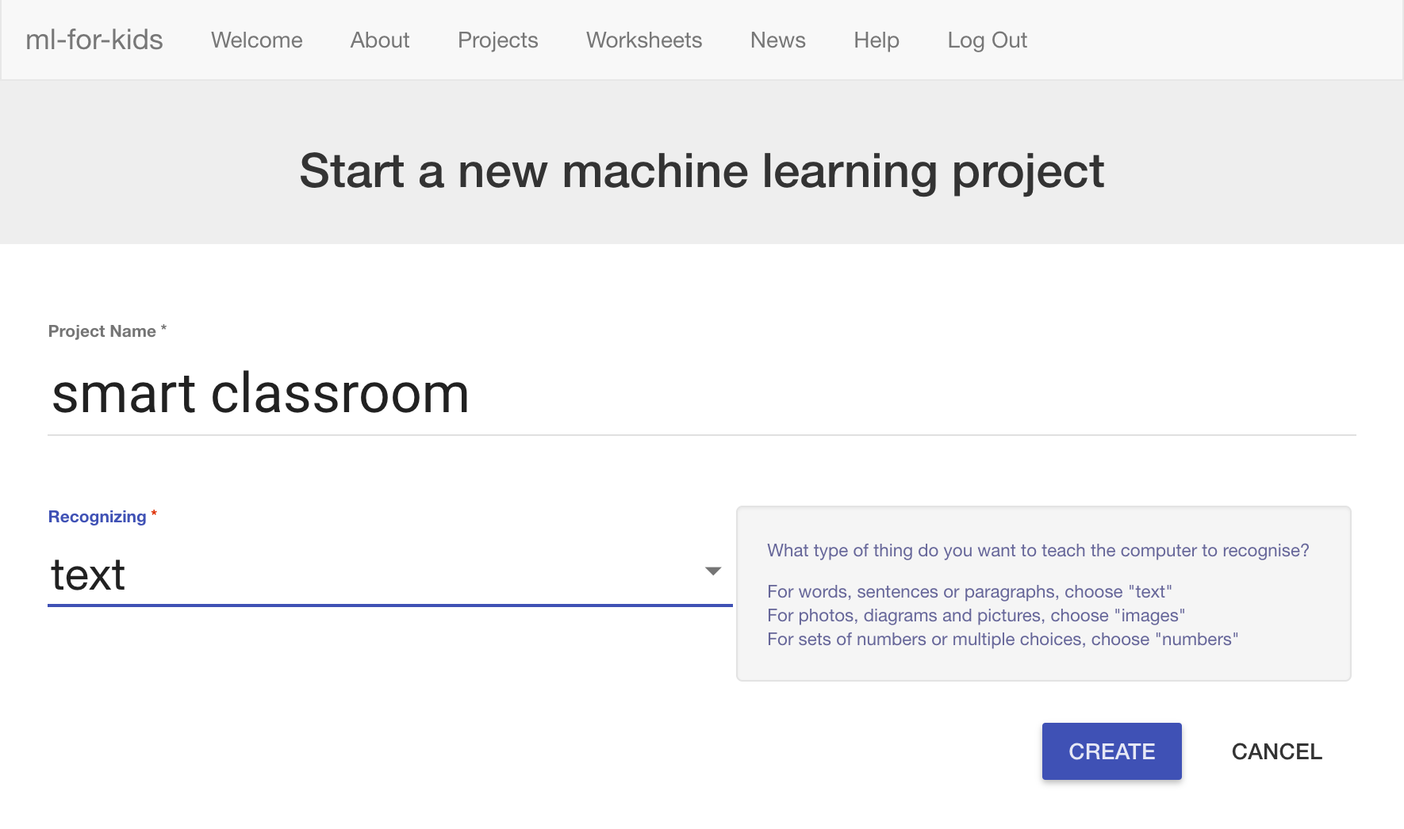

1. 你會在專案清單中看到“**smart classroom**”，點選此專案

You should see “smart classroom” in your projects list. Click it.  
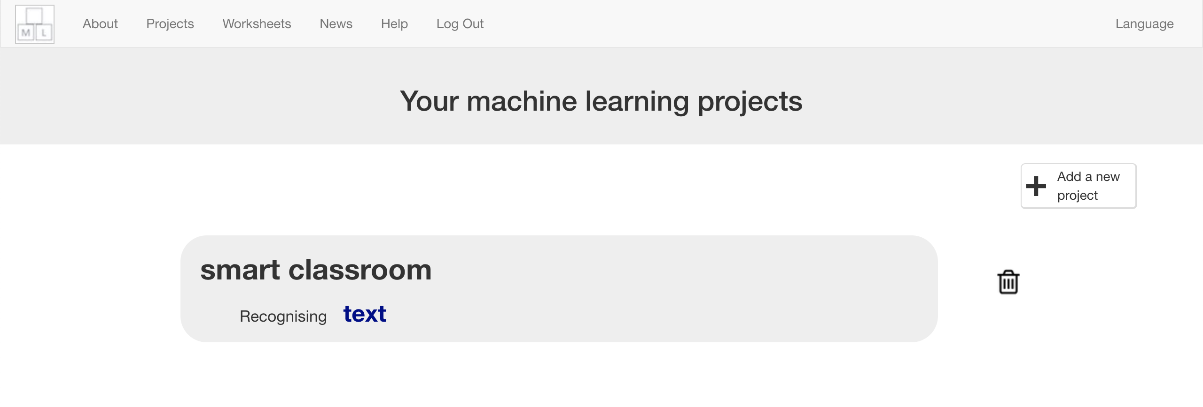

1. 我們要從一個Scratch已有的專案開始，點選“**Make**”按鈕

We’ll start by getting a project ready in Scratch. Click “**Make**”  
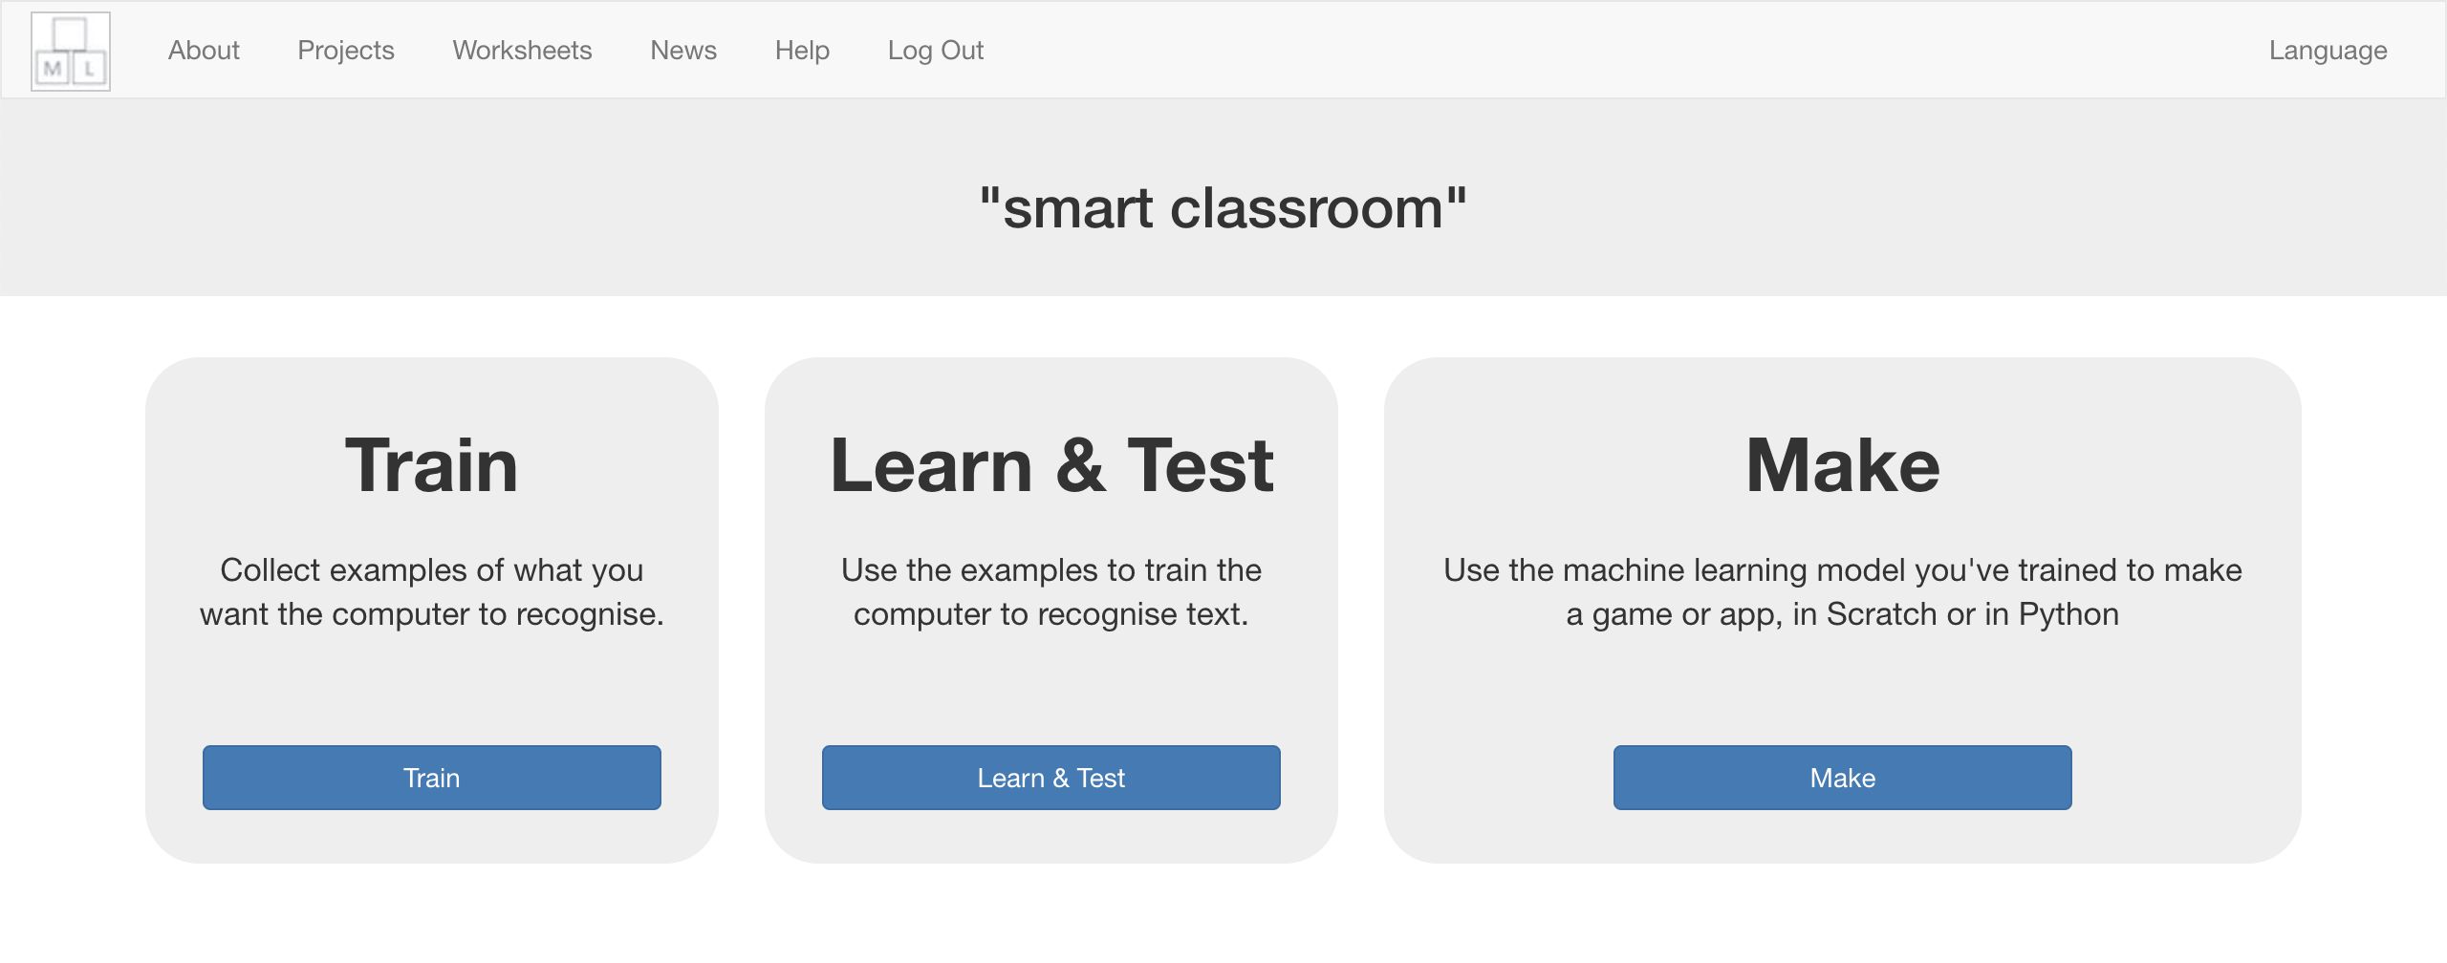

1. 點選“**Scratch**”

Click “**Scratch**”  
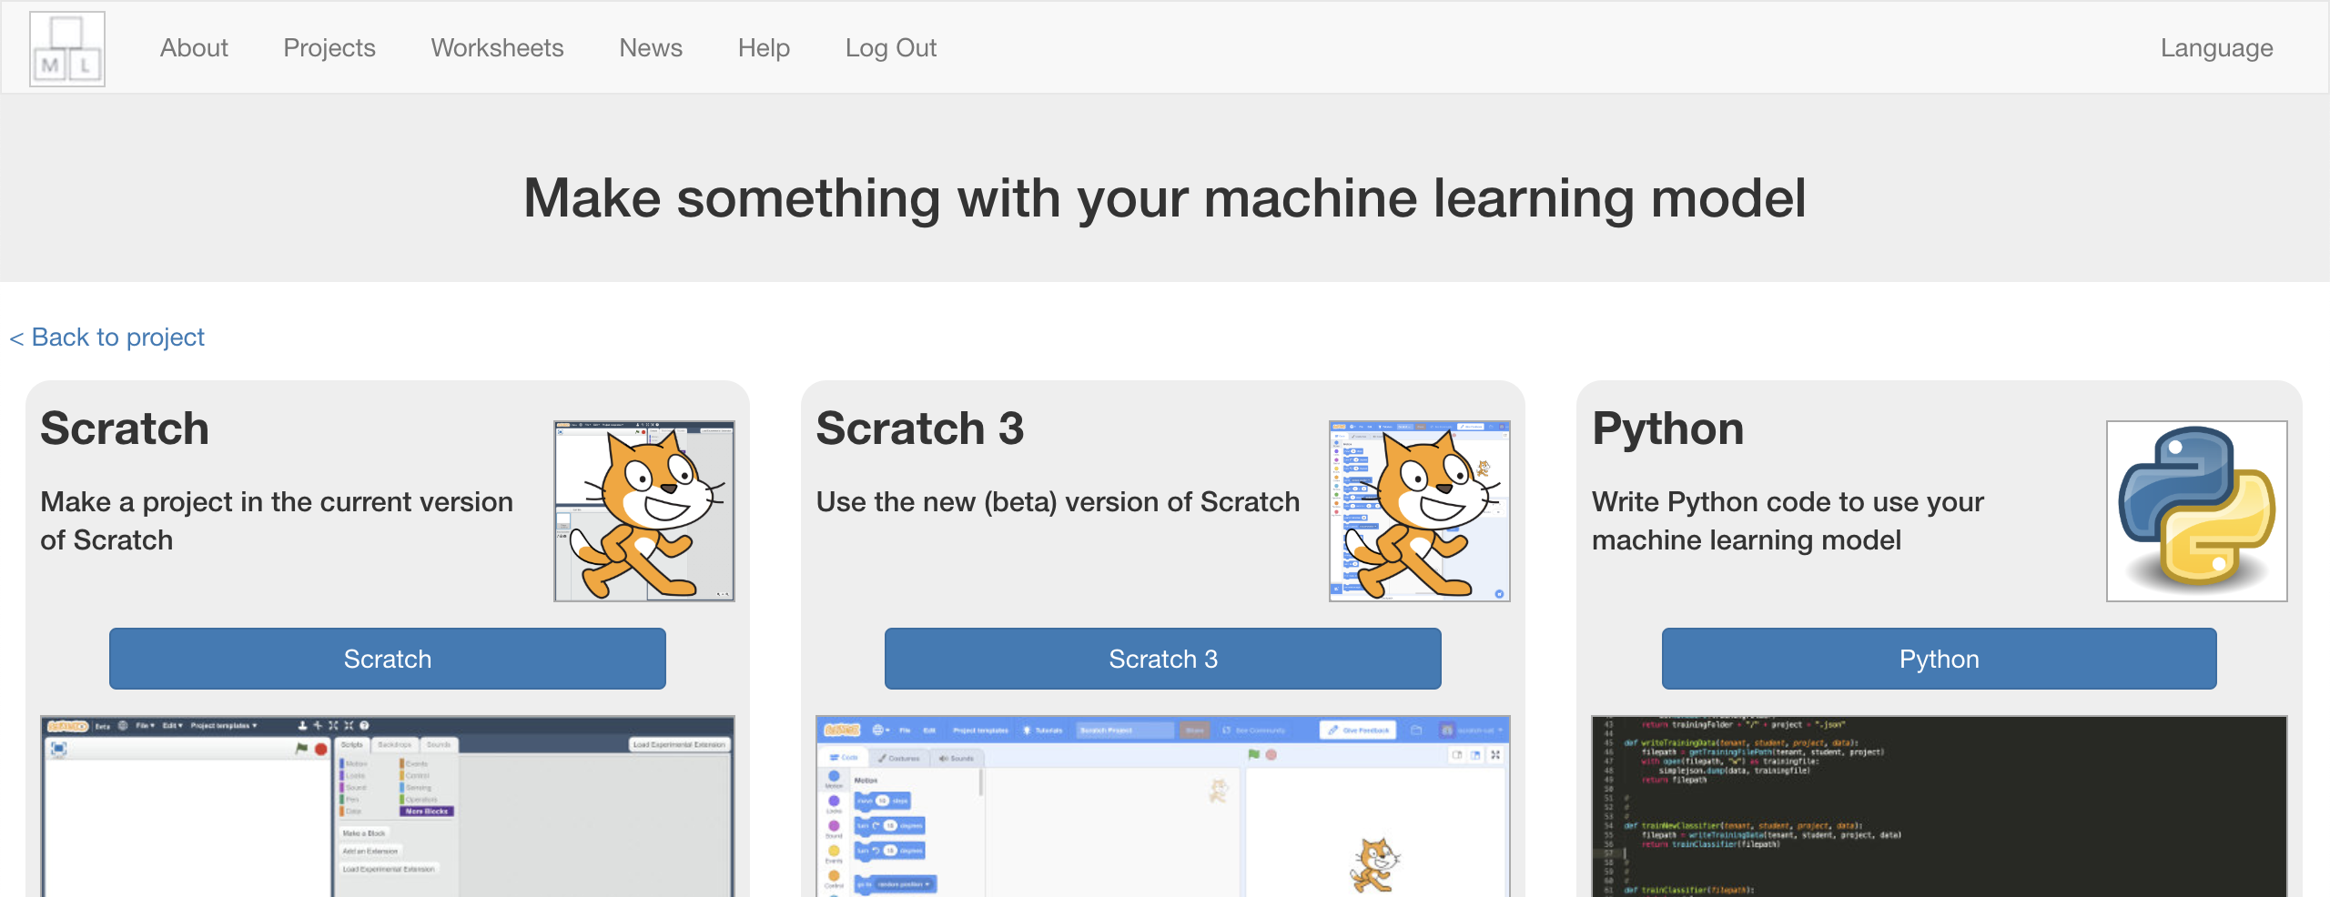

1. 點選“**Scratch by itself**”

Click “**Scratch by itself**”  
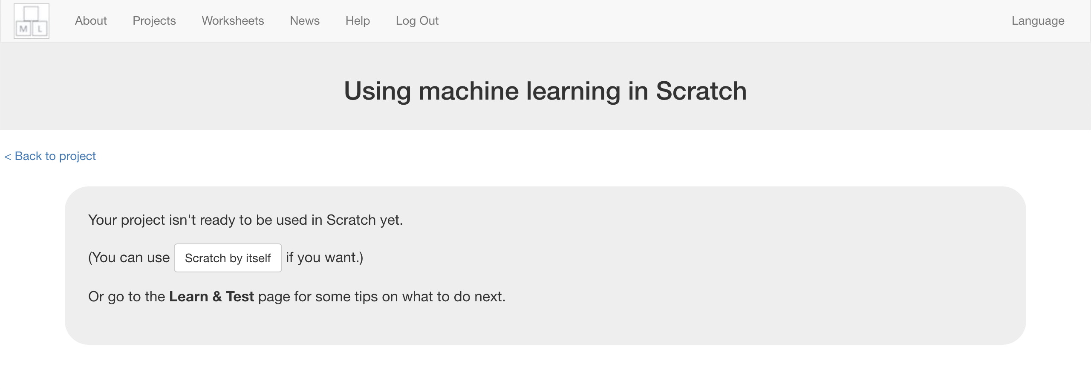

1. 載入**Smart Classroom (short)**

*點選Project templates ->再選擇Smart Classroom (short)*

Load the **Smart Classroom (short)** template   
*Click on Project templates -> Smart Classroom (short)*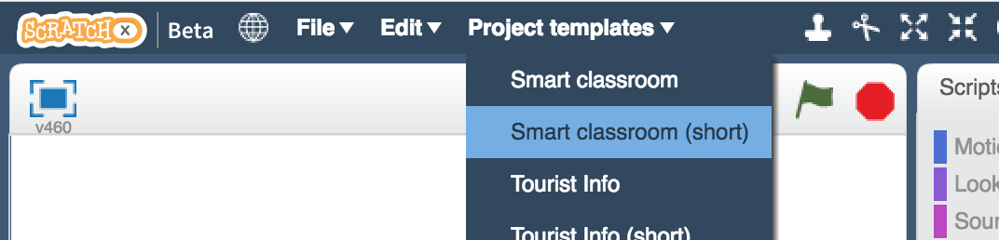

1. 點擊綠旗測試

Click on the **green flag** to test.   
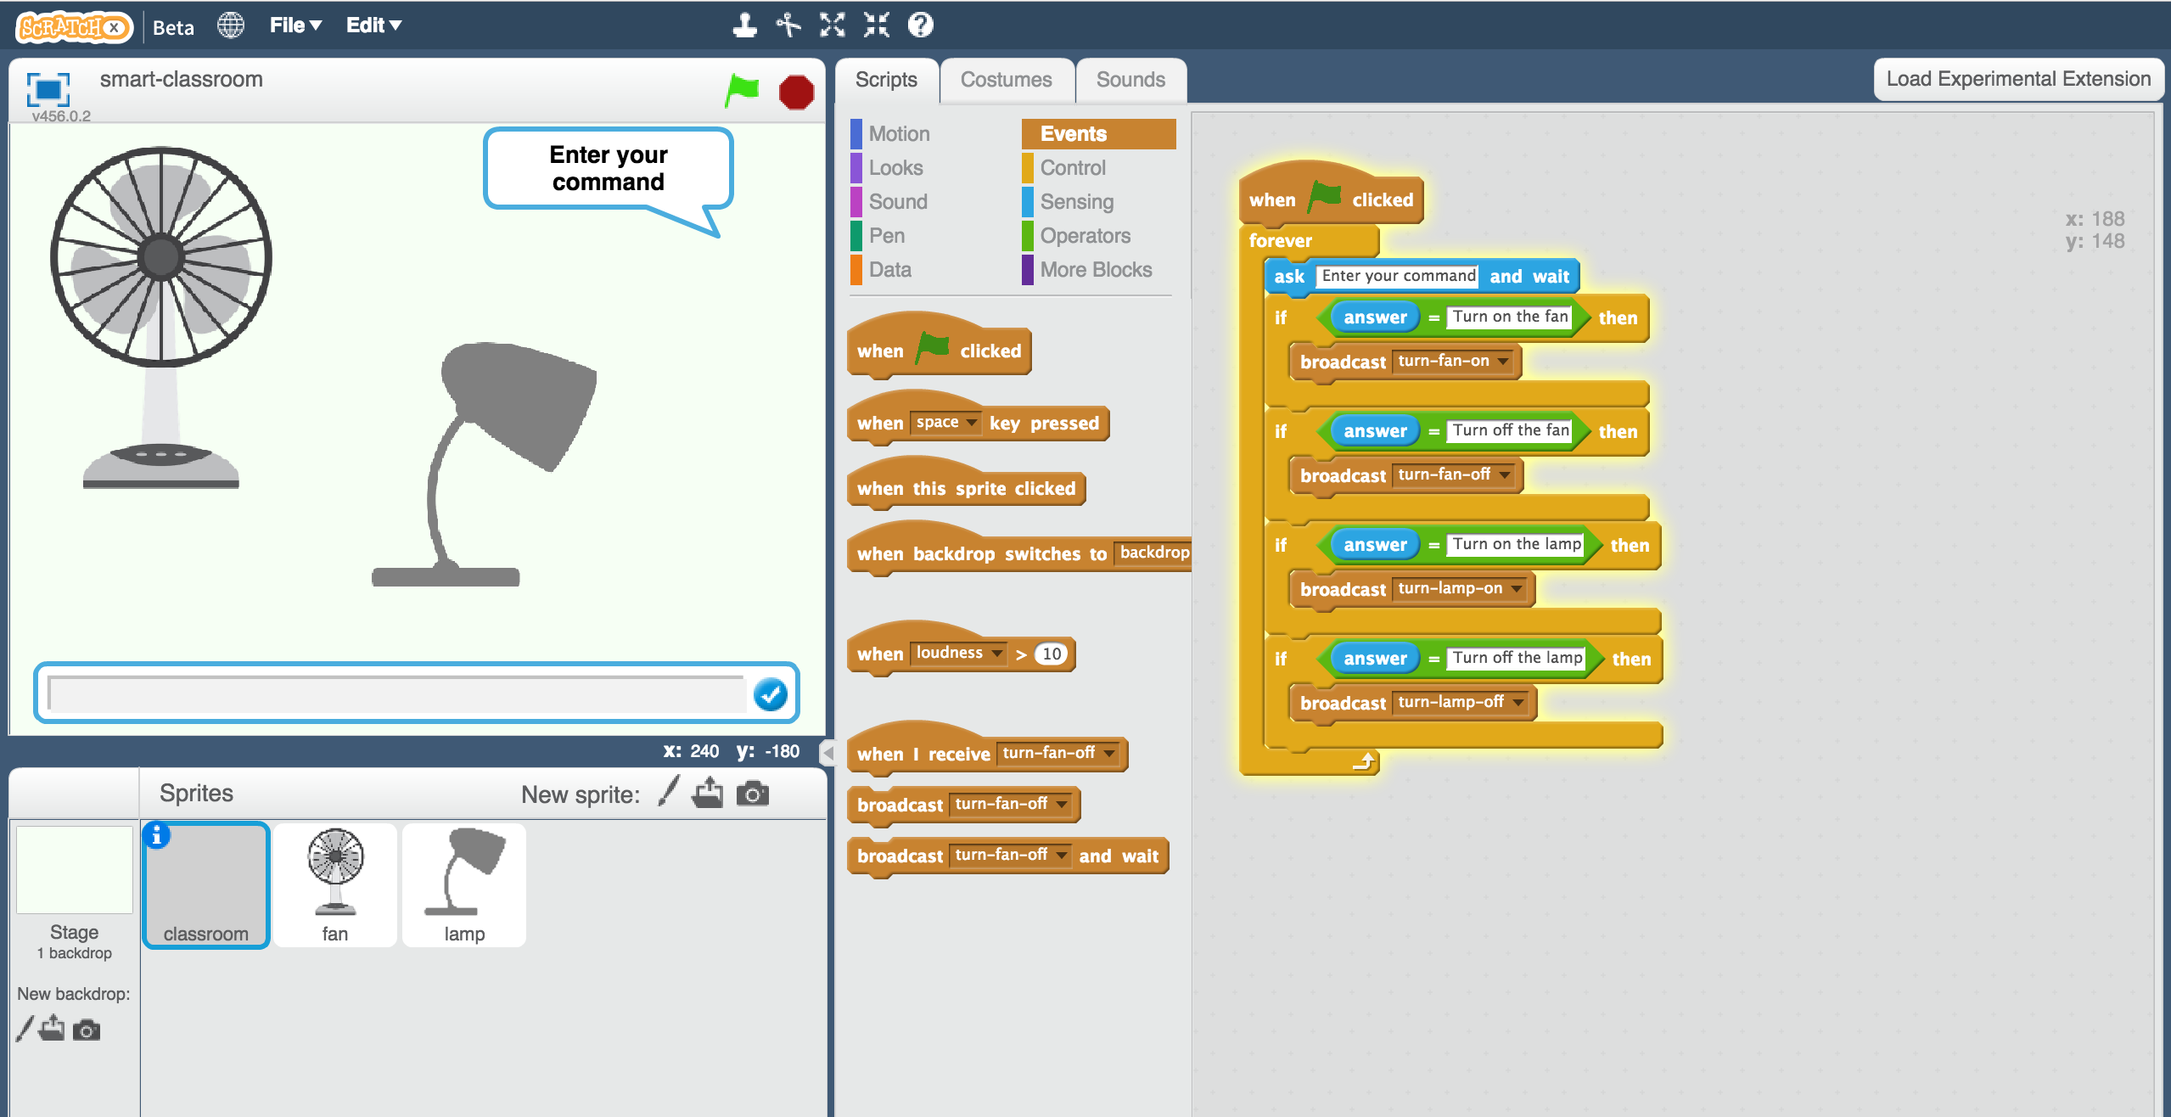

1. 輸入一條訊息並觀察發生了什麼事

試試看輸入*“Turn on the lamp”（開燈）、 “Turn off the lamp”（關燈）、“Turn on the fan”（開電扇）以及 “Turn off the fan”（關電扇），這些指令應該都可以正確執行。*

*試試看輸入其他指令，你會發現什麼事都沒發生，即使你只是拼錯字，也不會有任何事情發生。*

Type in a message and watch it react!  
*Try “Turn on the lamp”, “Turn off the lamp”, “Turn on the fan”, and “Turn off the fan”. They should all work.  
Type anything else, and nothing will happen!   
Even if you just make a small spelling mistake, it won’t match.*

1. 關掉Scratch視窗並回到訓練模型的網頁

Close the Scratch window and go back to the Training tool.

1. 點選“**< Back to project**”

Click on the “**< Back to project**”link.

1. 我們需要一些範例來訓練電腦。點選***Train***按鈕

We need to collect some examples to train the computer.   
*Click the* ***Train*** *button.*

1. 點選**“+ Add new label**”，加入四個方框，分別命名為：“fan on”、 “fan off”、 “lamp on”、 “lamp off”。

Click on **“+ Add new label**” and call it “fan on”.   
Do that again, and create a second bucket called “fan off”.  
Do that again, and create a third bucket called “lamp on”.  
Do that again, and create a fourth bucket called “lamp off”.  
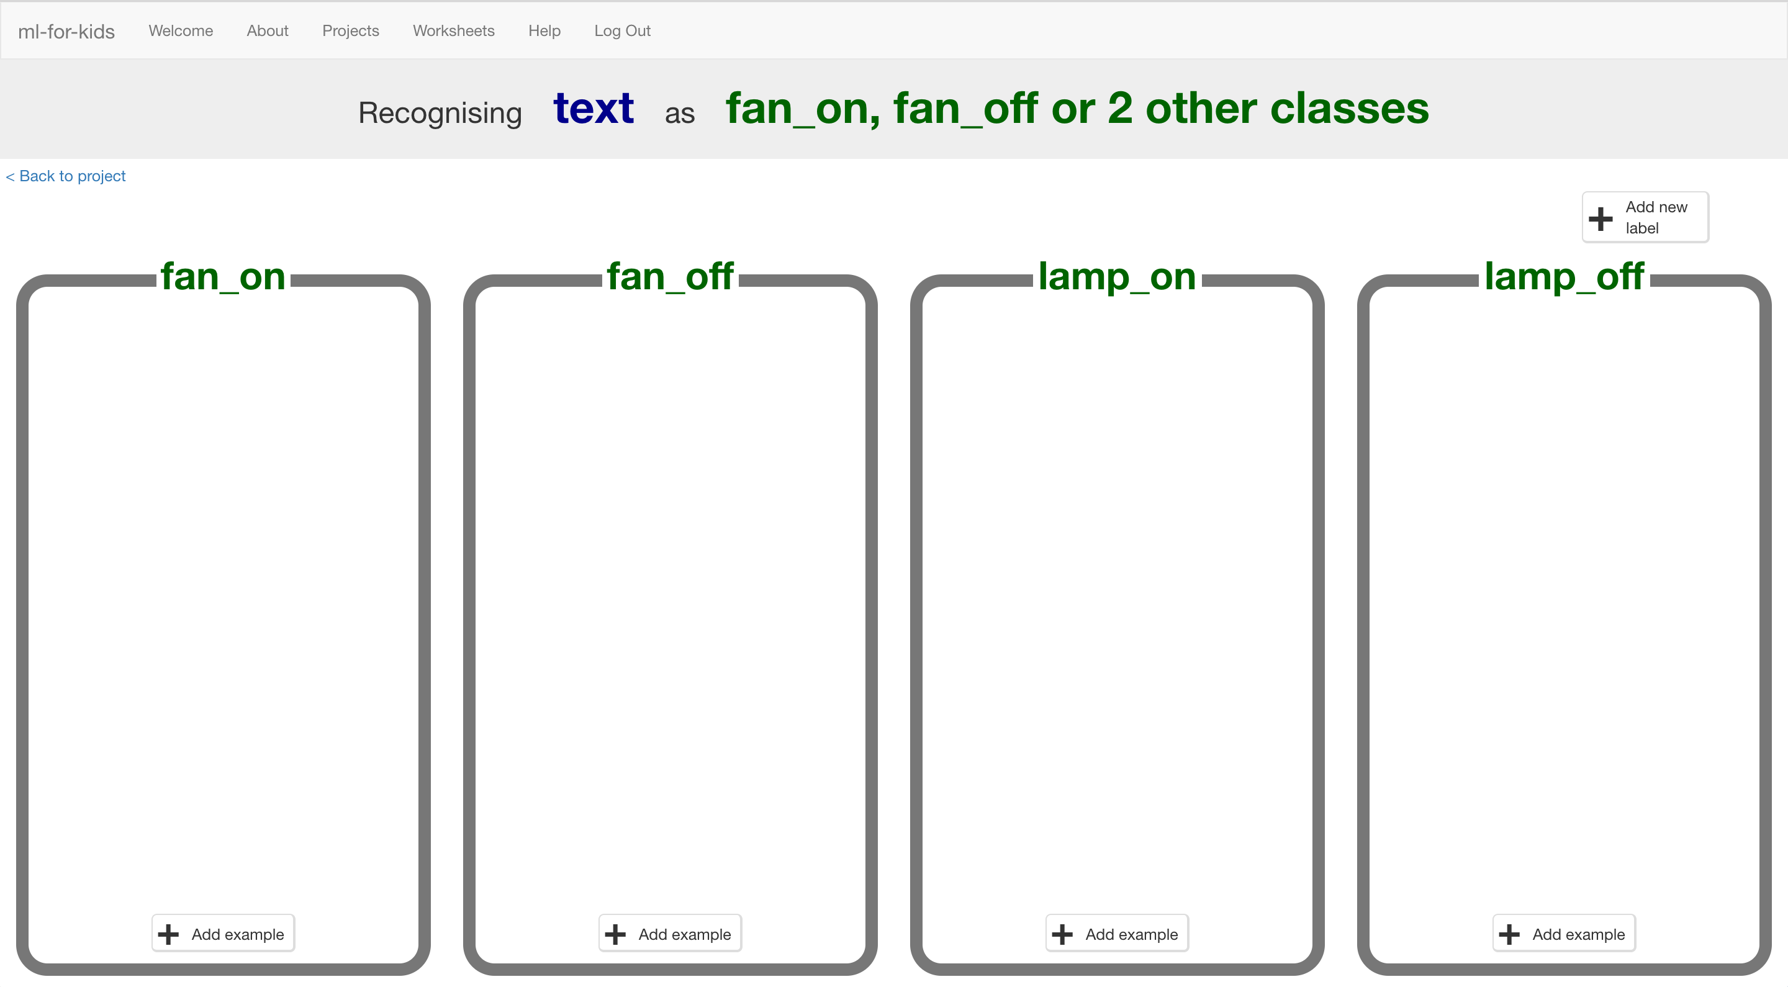

1. 點選“fan on”方框中的“**Add example**”按鈕，並輸入一句要求開電扇的指令。

*舉例來說，你可以輸入：Please can you switch on the fan（這些指令要用英文還是中文好？）*

Click on the “**Add example**” button in the “fan on” bucket, and type in a way to ask for the fan to be turned on.  
*For example, you could type “Please can you switch on the fan”.*

1. 點選“fan off”方框中的“**Add example**”按鈕，並輸入一句要求關電扇的指令。

*舉例來說，你可以輸入：I want the fan off now*

Click on the “**Add example**” button in the “fan off” bucket, and type in a way to ask for the fan to be switched off.  
*For example, you could type “I want the fan off now”*

1. 依照上面的方法，在“lamp on”和“lamp off”的方框中加入指令

Do the same for the “lamp on” and “lamp off” buckets.

1. 重複步驟18~20，直到每個方框中都至少有**六個**範例指令

*發揮你的想像力！*

*比如“fan on”， 你可以抱怨現在太熱了(It’s too hot)，“fan off”你可以說現在有點涼(It’s breezy)，“lamp on”你可以說太暗了什麼都看不到(It’s too dark that you can’t see)，“lamp off”則可以說現在太亮了(It’s too bright)*

Repeat steps 18-20 until you’ve got at least **six** examples of each.  
*Be imaginative!   
Try and think of lots of different ways to ask each command.   
For “fan on” you could complain that you’re too hot.   
For “fan off” you could complain that it’s too breezy.   
For “lamp on” you could complain that it’s too dark or that you can’t see.   
For “lamp off” you could complain that it’s too bright.*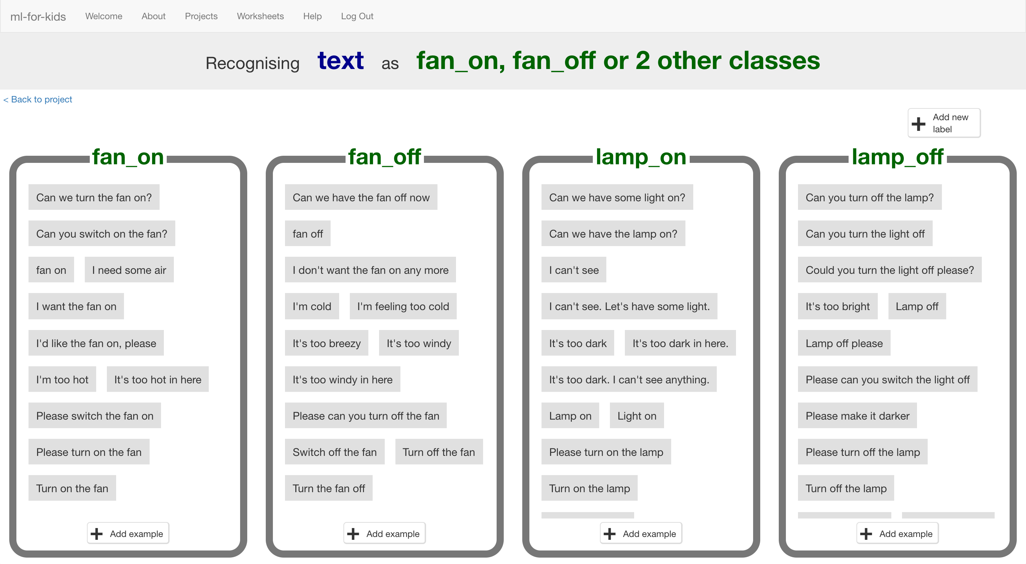

1. 點選**“< Back to project**”，再點選“**Learn & Test**”.按鈕

Click the **“< Back to project**” link, then click “**Learn & Test**”.

1. 點選“**Train new machine learning model**”按鈕。

只要蒐集夠多範例，電腦就可以開始學習分辨你給的不同指令。

Click on the “**Train new machine learning model**” button.   
*As long as you’ve collected enough examples, the computer should start to learn how to recognise commands from the examples you’ve written.  
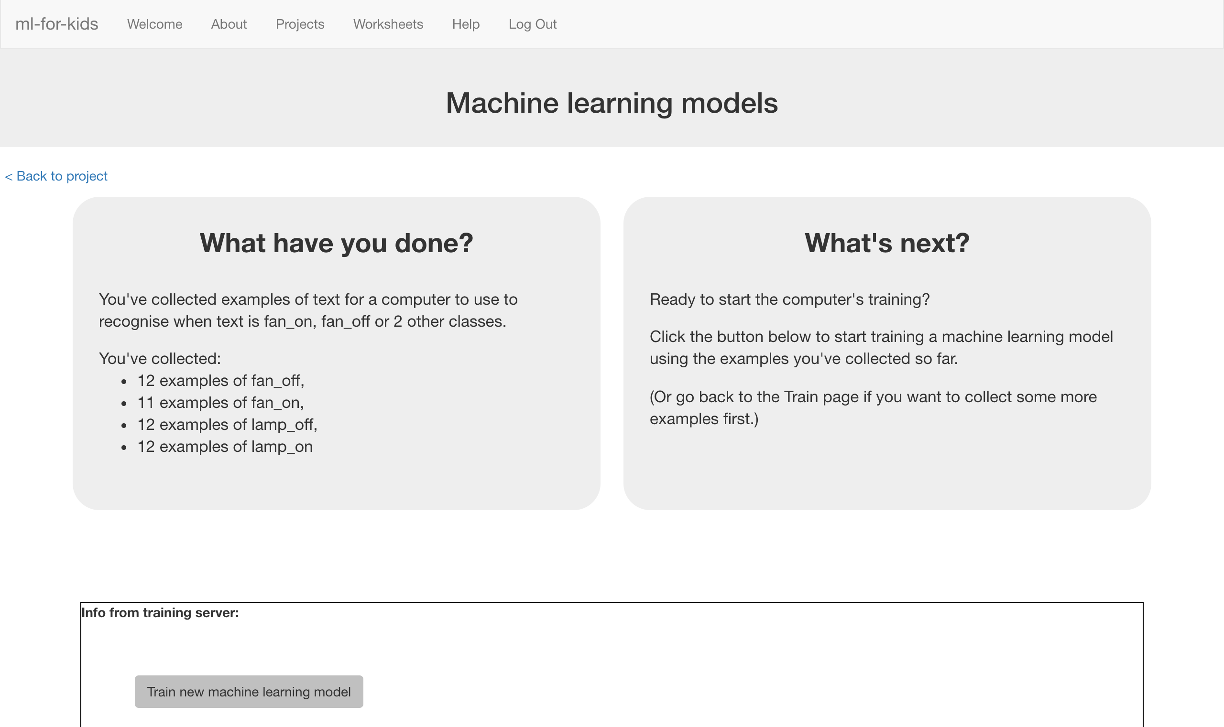*

1. 等待訓練完成，這可能需要一兩分鐘。

*在等待的時間裡，試著完成學習單最後一頁的小測試。*

Wait for the training to complete. This might take a minute or two.  
*While waiting, try to complete the machine-learning multi-choice quiz at the bottom of the page.*

1. 訓練完成後會出現一個測試方格。測試一下模型看看電腦學到些什麼。

輸入一條指令並按下enter鍵，模型應該能辨識出是哪一種指令。

*使用電腦沒看過的指令做測試。如果你對測試結果不滿意，回到步驟*

*18，加入更多範例指令，並確定你有重新訓練模型（至步驟23）！*

Once the training has completed, a Test box will be displayed.   
Try testing your machine learning model to see what the computer has learned.   
Type in a command, and press enter. It should be properly recognised as one of the four commands.  
 *Test it with examples that you haven’t shown the computer before.   
If you’re not happy with how the computer recognises the messages, go back to step 18, and add some more examples.   
Make sure you repeat step 23 to train with the new examples though!*

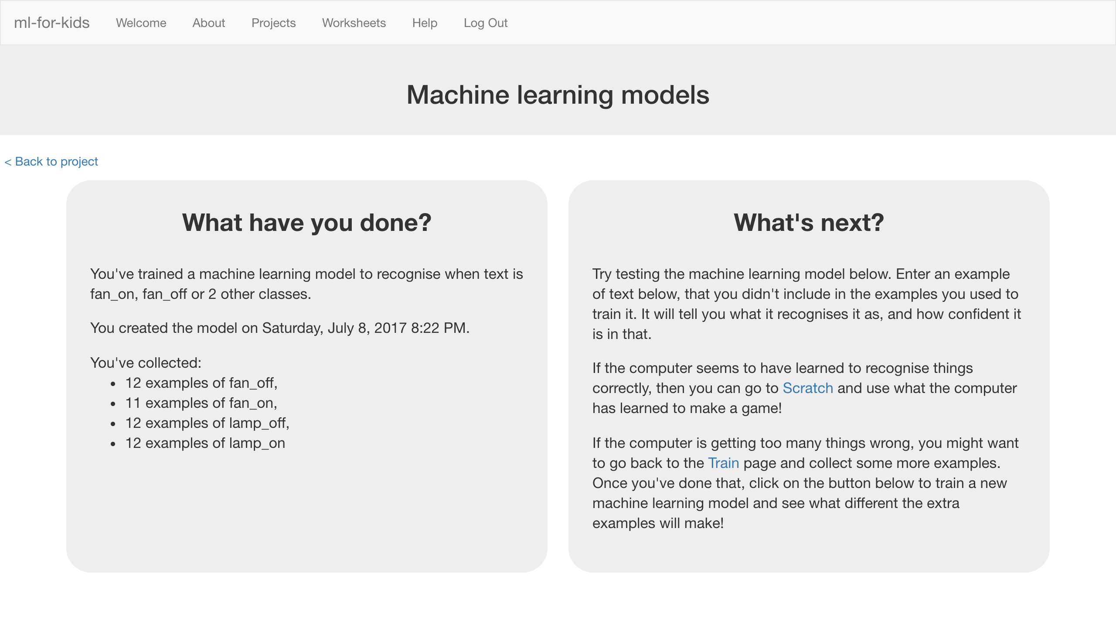

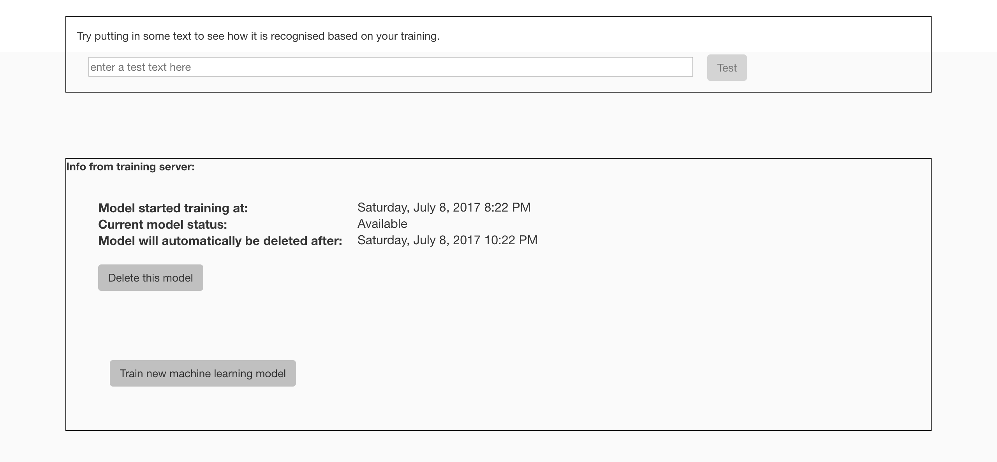

**到目前為止，你做了哪些事情？**

**What have you done so far?**

你開始訓練電腦辨別不同指令來操控教室裡的兩種物品。  
You’ve started to train a computer to recognise commands to control two classroom devices.

我們捨棄制定規則的方式，而是採用蒐集範例讓電腦學習的方法，這些範例會被用來訓練一個機器學習『模型』。

Instead of trying to write rules to be able to do this, you are doing it by collecting examples. These examples are being used to train a machine learning “model”.

這就是所謂的『監督式學習』(supervised learning)，因為你給電腦訓練用的範例都確保是正確的，就像是在監督它一樣。

This is called “supervised learning” because of the way you are supervising the computer’s training.

電腦會從範例中尋找共通模式，比如文字的使用、句子的結構等，這些都會被用在辨別新的指令。

The computer will learn from patterns in the examples you’ve given it, such as the choice of words, and the way sentences are structured. These will be used to be able to recognise commands.

1. 點選**“< Back to project**”

Click on the **“< Back to project**” link

1. 點選“**Make**”

Click “**Make**”

1. 點選“**Scratch**”

Click the “**Scratch**” button

1. 點選“**Open in Scratch**”

Click “**Open in Scratch**”  
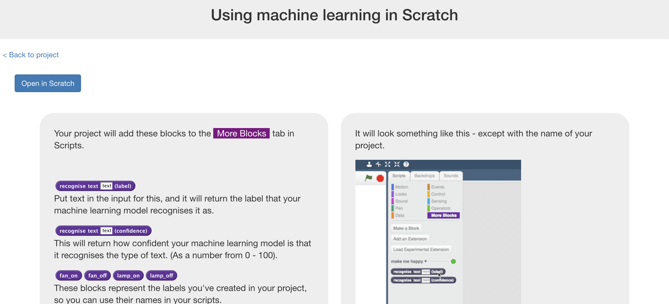

1. 你應該在專案裡的『更多積木』(More blocks)區看到新積木

*You should see new blocks in the “More blocks” section from your   
“smart classroom” project.*  
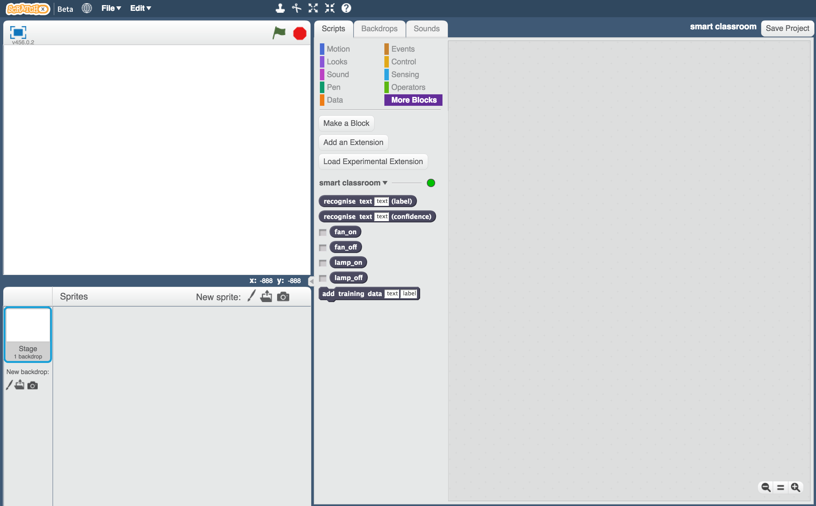

1. 重新載入剛剛的Scratch專案。

*點選 檔案->載入專案，當電腦詢問是否覆蓋目前專案時點選OK*

Load the same starter Scratch project you opened before.  
*Click on* ***File*** *->* ***Load Project****Click OK when it asks to replace the current project*

**小技巧**

**Tips**

多一點範例！

**More examples!**

當你給越多範例，電腦就能更好的辨別指令

The more examples you give it, the better the computer should get at recognising your instructions.

**蒐集相同數目的指令**

**Try and be even**

盡可能讓每種指令的範例數量一樣多

Try and come up with roughly the same number of examples for each command.

如果你其中一種指令特別多，那麼電腦可能會更容易將指令判別成這一類，因此會影響到電腦辨識指令的學習

If you have a lot of examples for one command, and not the others, the computer might learn that command is more likely, so you’ll affect the way that it learns to recognise messages.

**確保範例中有各種圖片**

**Mix things up with your examples**

試著找到不同類別的範例

Try to come up with lots of different types of examples.

舉例來說，確認你的範例中包含了一些很長的指令和一些非常短的指令。

For example, make sure that you include some long examples and some very short ones.

1. 點選『程式』，拖曳程式積木（如下圖），取代專案裡原有程式。

*“recognise text … (label)”是此專案新增的積木。當你給了一條訊息，他會依據先前訓練判斷是哪種命令，並回傳一個值(label)*

Click on the “**Scripts**” tab, and update the script to use your machine learning model **instead** of the rules that are already there.  
*The “recognise text … (label)” block is a new block added by your project. If you give it text, it will return the label for one of the four commands based on the training you’ve given to the computer.*  
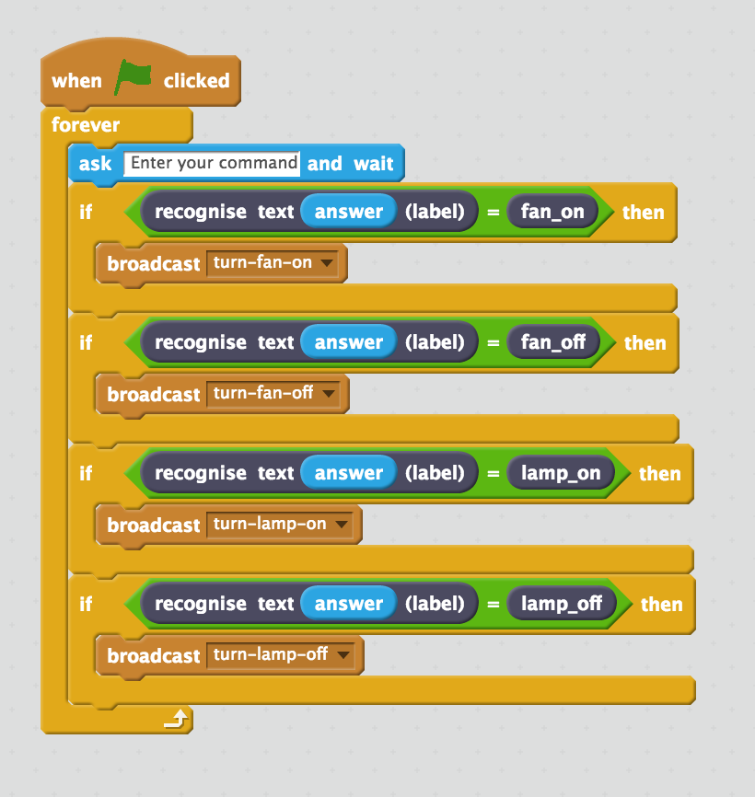

1. 點擊綠旗

Click the **green flag** to test again.   
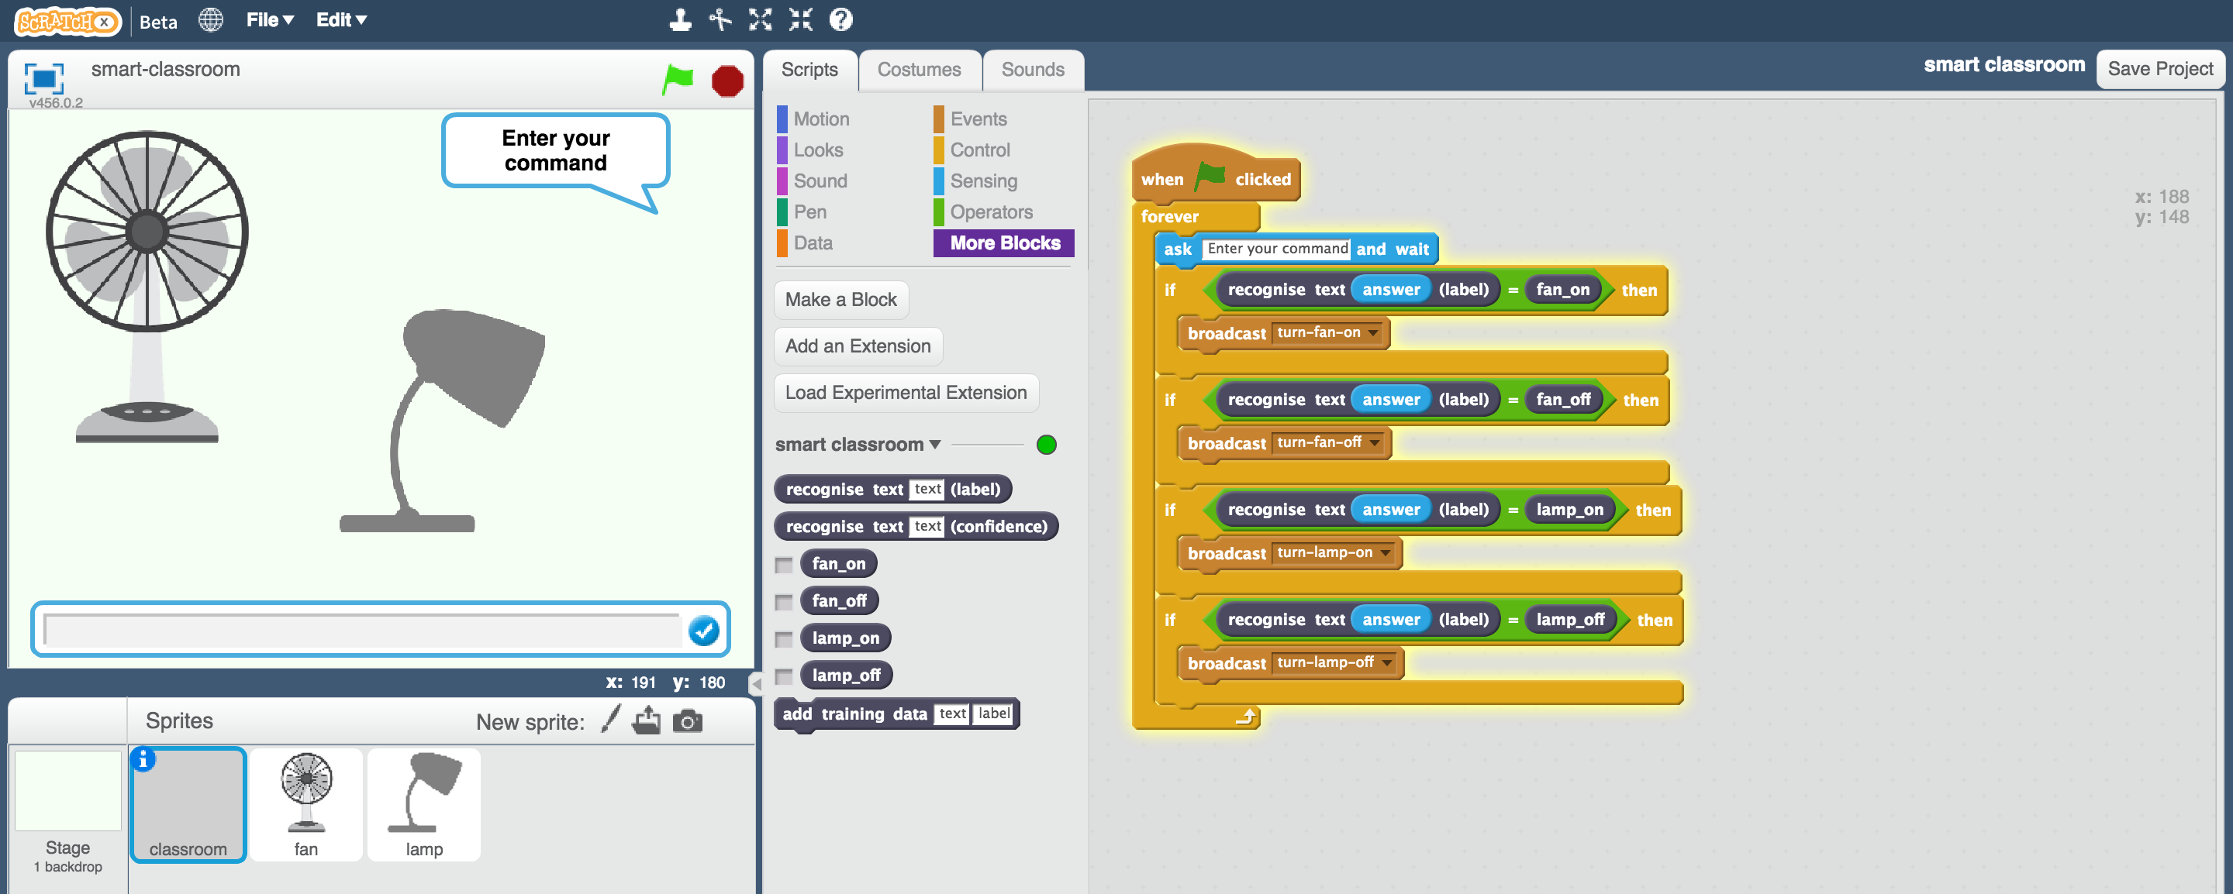

1. 進行測試

*輸入一條指令並按下enter鍵，電風或風扇就會依照指令運作。*

*確認你所使用的測試指令沒有在前面的訓練中使用過。*

Test your project  
*Type a command and press enter. The fan or lamp should react to your instructions.   
Make sure you test that this works* ***even for messages that you didn’t include in your training****.*

1. 存檔

點選 檔案-> 儲存專案

Save your project.  
*Click* ***File*** *->* ***Save Project***

到目前為止，你做了哪些事情？

**What have you done so far?**

你調整了Scratch的智慧教室專案，讓他不再是依照寫好的規則執行專案，而是使用機器學習的方式執行。

You’ve modified your Scratch smart classroom assistant to use machine learning instead of your earlier rules-based approach.

訓練電腦自己辨識指令比試圖列出所有可能出現的指令來得有效率。

Training the computer to be able to recognise instructions for itself should be much quicker than trying to make a list of every possible command.

當你給了越多範例，電腦的辨識結果正確率就應該越高

The more examples you give it, the better it should get at recognising instructions correctly.

1. 回到訓練模型視窗的**Learn & Test**頁面，但先不要關掉Scratch，我們晚點還會用到。

在**Learn & Test**頁面的測試方格裡輸入一條跟電燈和電扇都無關的指令。

*比如，輸入make me a cheese sandwich（幫我做一個起司三明治）。*

Leave Scratch open (we’ll come back in a moment) but go back to the **Learn & Test** page in the Training tool.  
Type a message into the Test box that has nothing to do with lamps or fans.   
*For example, “make me a cheese sandwich”*  
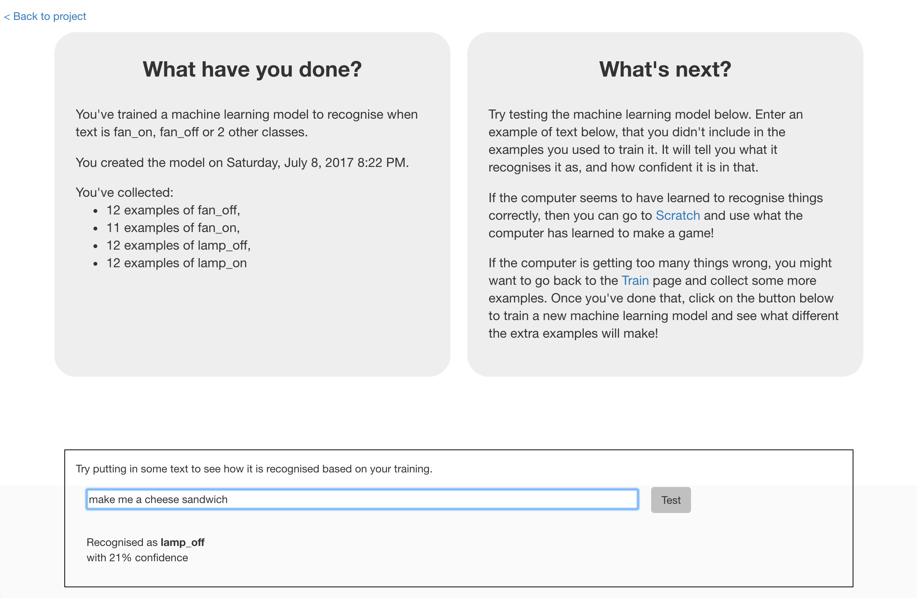

1. 查看信心分數(confidence score)，你會發現分數很低。

輸入另一個指令turn on the lamp（開燈），比較兩條指令的信心分數。

***電腦是在告訴你他不是那麼確定你所下達的指令，因為這條指令跟從範例中學到的很不一樣***

Look at the confidence score, and check that it’s very low. Compare this with the score you get from commands like “turn on the lamp”.   
***This is the computer’s way of telling you that it’s not very certain it understands your command, because it doesn’t look like what it learned from your examples.***

1. 回到Scratch

Go back to Scratch.   
*You can open your saved project from before if you closed the window.*

1. 更新角色“classroom”的程式，加入信心分數的積木(confidence score)

Modify the script for the “classroom” sprite so that it uses this confidence score.  
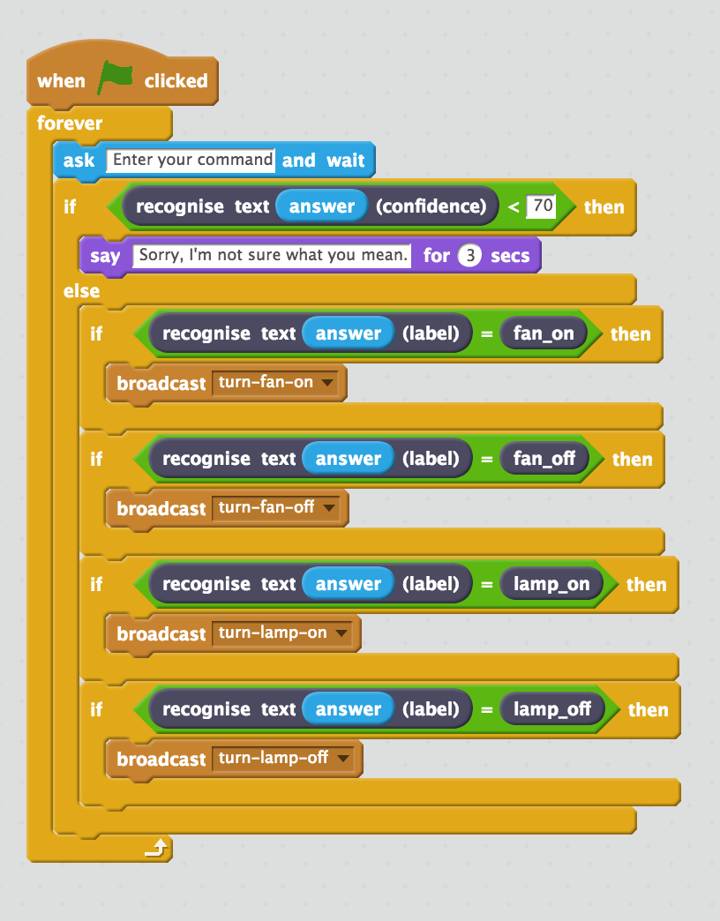

1. 點擊綠旗

*試試輸入一條跟電扇與電燈都無關的指令、試試要求關掉某項物件，看看是否都能正確執行。*

Click the **green flag** and test again  
*Try typing commands that have nothing to do with the fan or lamp.   
Try asking for something to be turned on or off.   
Check that your classroom reacts in the right way.*

1. 存檔

Save your project  
*You’ve finished!*

**你完成了哪些東西？**

**What have you done?**

你訓練了一個簡單的智慧助理。智慧助理就是那種在現代手機裡或是虛擬助理裝置上協助使用者的軟體。（像是Apple手機上的Siri、Android手機上的Google助理、Amazon的Alexa、Google’s Home等等）

You’ve trained a smart assistant – like a simple version of the assistants you can get on modern smartphones (like Apple’s Siri or Google’s Assistant) or virtual assistant devices (like Amazon’s Alexa or Google’s Home).

你使用機器學習，在Scratch中創造了一個智慧教室助理，而不是使用以前那種寫規則的方法。

You’ve used it to create a smart classroom assistant in Scratch, using machine learning instead of your earlier rules-based approach.

訓練電腦自己辨識指令比試圖列出一長串可能出現的指令容易得多。而且當給了越多範例，電腦的辨識結果越好。

Training the computer to be able to recognise instructions was hopefully much easier than trying to make a list of every possible command. And the more examples you give it, the better it gets at recognising instructions and the more confident it gets in doing that.

接下來，如果電腦不確定你的指令內容，他會要求你再試一次。

And now, if it’s not sure what you mean, it will ask you to try again.

**延伸活動**

**Ideas and Extensions**

現在你已經完成了這個專案，要不要試試下面的點子？或者，自己想一個？

Now that you’ve finished, why not give one of these ideas a try?

**試試其他裝置**

**Try another device**

除了電燈和電扇，你能為你的智慧教室加入其他裝置嗎？

Instead of just a fan and a lamp, can you add another device to your smart classroom?

**嘗試不同信心基準點**

**Try different confidence limits**

對於電腦是否有把握正確辨別一條指令，70%會是一個好的基準點嗎？

Is 70% the right threshold to use to decide whether the computer has recognised the command?

實驗各種不同數值，直到你的機器學習模型可以順利運作

Experiment with different values until you have a value that works well for your machine learning model.

如果你選了一個太高的基準點，電腦很容易回答：抱歉，我不懂你在說什麼。

If you choose a number that is too high, the computer will say “Sorry I’m not sure what you mean” too often.

而如果你選了一個太低的基準點，電腦又會太容易辨別錯誤。

If you choose a number that is too low, the computer will get too many things wrong.

**搬到現實生活中！**

**Do it for real!**

研究一下Amazon的智慧助理Alexa：<http://amzn.to/2sxy1hw>

Have a look at the smart assistants that developers have made for Amazon’s Alexa : <http://amzn.to/2sxy1hw>

開發者使用的是跟你一樣的方式：幫各種類別指令建立不同的標籤方框，然後蒐集指令訓練Alexa。

Developers made these in the same way that you did this project – creating labels for the commands they wanted it to recognise, and then collecting examples of how those commands might be phrased to train the Alexa to be able to understand them.

找一個你覺得很棒的Alexa功能，研究Alexa可以理解的指令，你能想到該怎麼訓練Alexa嗎？

Find an Alexa Skill that you think sounds good. Look at the commands it can understand – can you think how you could’ve trained it?